# Project: Analyzing a Market Test

Complete each section. When you are ready, save your file as a PDF document and submit it [here](https://classroom.udacity.com/nanodegrees/nd008/parts/11a7bf4c-2b69-47f3-9aec-108ce847f855/project).

## Step 1: Plan Your Analysis

*To perform the correct analysis, you will need to prepare a data set. (500 word limit)*

*Answer the following questions to help you plan out your analysis:*

1. What is the performance metric you’ll use to evaluate the results of your test?

To evaluate the results of our test, I would use gross margin because as per the problem there should be at least 18% increase in profit growth compared to the comparative period while compared to the control stores; otherwise known as *incremental lift*.

1. What is the test period?

The test period is 12 weeks (2016-April-29 to 2016-July-21).

1. At what level (day, week, month, etc.) should the data be aggregated?

The data should be aggregated at week’s level.

## Step 2: Clean Up Your Data

*In this step, you should prepare the data for steps 3 and 4. You should aggregate the transaction data to the appropriate level and filter on the appropriate data ranges. You can assume that there is no missing, incomplete, duplicate, or dirty data. You’re ready to move on to the next step when you have weekly transaction data for all stores.*

The trend tool is used to create trend and seasonality variables to use as control variables. To do this, we need at least 52 weeks of data, plus the number of weeks we select in the tool to calculate trend, before the beginning of the test start date. For the project, we are asked to use 12 weeks to calculate trend, so we'll need 64 (52weeks +12)weeks of data prior to the test start date. Since the test lasts for 12 weeks (2016-April-29 to 2016-July-21), this means we'll need a total 76 weeks of data. We have checked this in our alteryx workflow by summarizing tool and got count of distinct weeks for each store as 76. In Alteryx the expression for 76 weeks looks like [Invoice Date]>="2015-02-06" AND [Invoice Date]<"2016-07-22".

Thereafter, we create four new fields week (assigned week 1 to the first week of the test period), week start(test start date), week end and new_product_flag using Floor, DateTimeDiff, and DateTimeAdd functions.

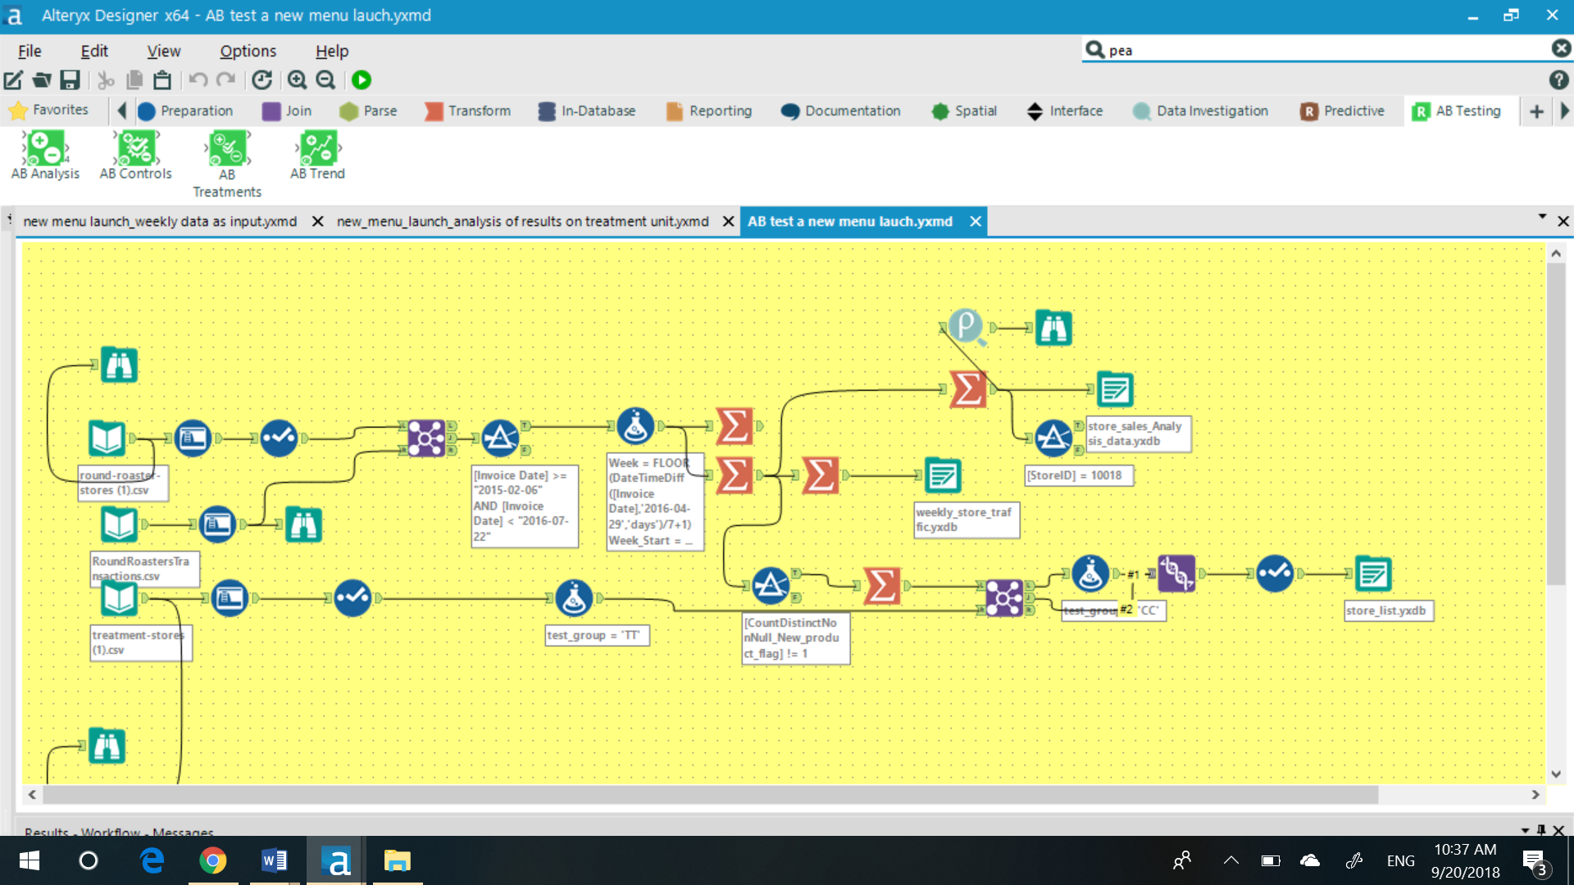

## Step 3: Match Treatment and Control Units

*In this step, you should create the trend and seasonality variables, and use them along with you other control variable(s) to match two control units to each treatment unit. Note: Calculate the number of transactions per store per week to calculate trend and seasonality.*

*Apart from trend and seasonality...*

1. What control variables should be considered? Note: Only consider variables in the RoundRoastersStore file.

The potential numerical control variables from RoundRoastersStore file are AvgMonthSales and Sq_Ft.

1. What is the correlation between your each potential control variable and your performance metric?

The correlation between each potential control variable (Sq_Ft and AvgMonthSales) and performance metric(sum_weekly_gross_margin) as per pearson Correlation table is as given below:

**Pearson Correlation table**

|  |  |  |  |
| --- | --- | --- | --- |
|  | AvgMonthSales | Sq_Ft | Sum_Sum_Gross |
| AvgMonthSales | 1 | -0.046967 | 0.790358 |
| Sq_Ft | -0.046967 | 1 | -0.019345 |
| Sum_Sum_Gross Margin | 0.790358 | -0.019345 | 1 |

Hence, the target variable (performance metric)- Gross Margin is highly correlated to AvgMonthSales as the correlation coefficient is high 0.79.

The variable Sq_Ft is correlated with Gross margin as the value(-0.019) is very close to zero. So, we will drop this.

1. What control variables will you use to match treatment and control stores?

We will use AvgMonthSales along with Trend and seasonality to match treatment and control stores.

1. Please fill out the table below with your treatment and control stores pairs:

|  |  |  |  |
| --- | --- | --- | --- |
| Treatment Store | Control Store 1 | Control Store 2 | Distance |
| 1664 | 1857 |  | 0.175361 |
| 1664 |  | 7484 | 0.20393 |
| 1675 | 2114 |  | 0.037851 |
| 1675 |  | 8562 | 0.206081 |
| 1696 | 1964 |  | 0.070835 |
| 1696 |  | 7584 | 0.144805 |
| 1700 | 1508 |  | 0.319027 |
| 1700 |  | 7384 | 0.617783 |
| 1712 | 7284 |  | 0.136973 |
| 1712 |  | 8212 | 0.185993 |
| 2288 | 9081 |  | 0.177731 |
| 2288 |  | 12069 | 0.545573 |
| 2293 | 11568 |  | 0.155899 |
| 2293 |  | 12219 | 0.275412 |
| 2301 | 10018 |  | 0.127935 |
| 2301 |  | 10468 | 0.245981 |
| 2322 | 2409 |  | 0.171431 |
| 2322 |  | 3102 | 0.20773 |
| 2341 | 2333 |  | 0.119963 |
| 2341 |  | 11368 | 0.276433 |
|  |  |  |  |

## Step 4: Analysis and Writeup

*Conduct your A/B analysis and create a short report outlining your results and recommendations. (250 words limit)*

*Answer these questions. Be sure to include visualizations from your analysis:*

1. What is your recommendation - Should the company roll out the updated menu to all stores?

The company should roll out the updated menu to all scores as per the A/B analysis of central and west region as given below. The increase in profit is much more than 18% (which was the minimum requirement to take care of advertising expenditure) as per the results

1. What is the lift from the new menu for West and Central regions (include statistical significance)?

The lift from the new menu for West and Central regions is 32.1 and 36.3 respectively. The statistical significance for west region is 99.1 and for central region is 99.2.

**For Central Region:**

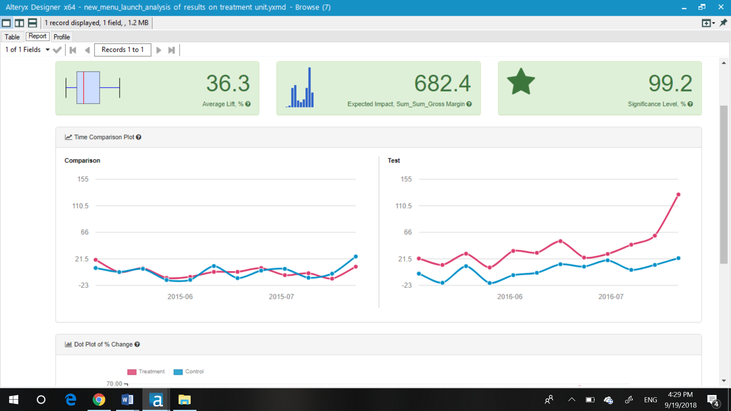

For West region:

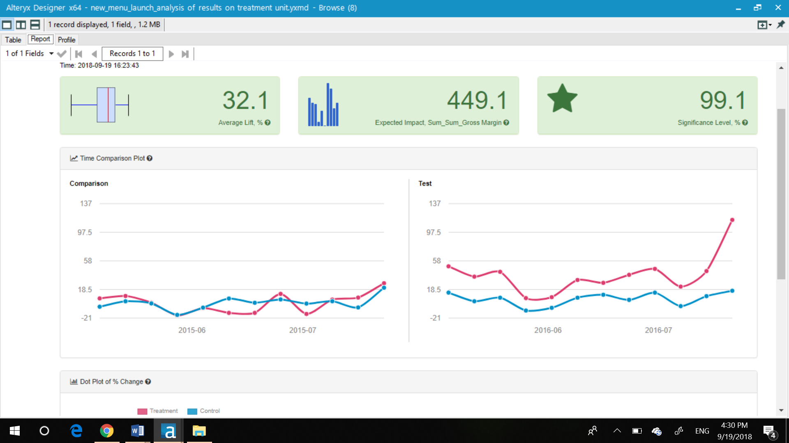

1. What is the lift from the new menu overall?

The lift from new menu overall is 34.2%

**New menu overall**

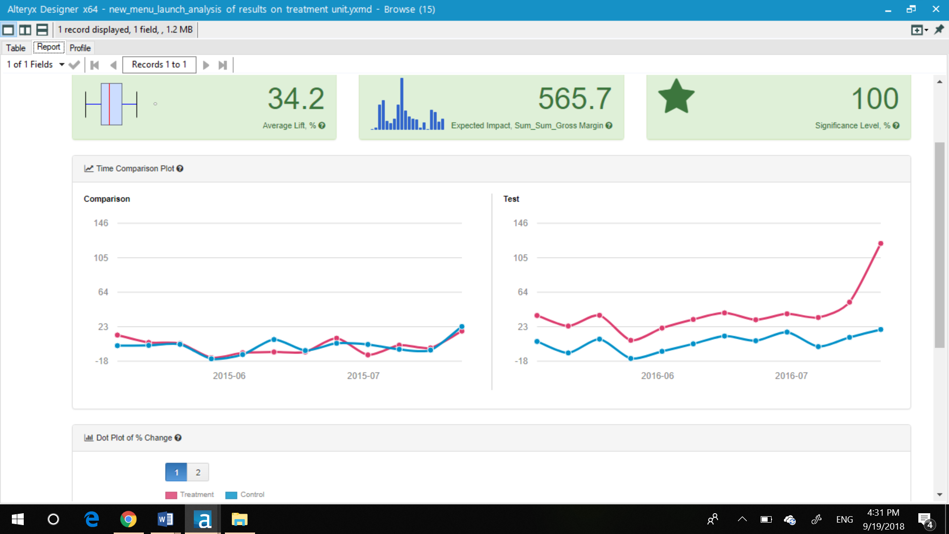

## Before you Submit

Please check your answers against the requirements of the project dictated by the [rubric](https://review.udacity.com/#!/rubrics/287/view) here. Reviewers will use this rubric to grade your project.